CST 240
LAB 6: ptheads

1. (60 pts) Check out the rsa_en_dec.c program in the Week 9 folder in Canvas under HW 7: Threads. The program computes:

result = base^{exponent} % modulus

NOTE: result might overflow depending on values of base, exponent, modulus. Do NOT fret over overflowing results. We won’t really care what the result is here. We only care how long it takes to do the loop.

a. Let
base = 123456781
exponent = 2111222331
modulus = 666666666

Run rsa_en_dec.c with above values. How long in seconds did it take to derive “result”?

18.547650 seconds

b. Revise rsa_en_dec.c and call it rsa_rev_a.c to compute 10 “result”s . In consecutive “result”s, modulus and base remain the same as in part 2. Consecutively, exponents are:

exponent = 2111222330
exponent = 2111222333
exponent = 2111222332
exponent = 2111222334
exponent = 2111222331
exponent = 2111222336
exponent = 2111222335
exponent = 2111222338
exponent = 2111222337
exponent = 2111222339

When done, type:
$ gcc -o rsa_rev_a.out rsa_rev_a.c
$ time ./rsa_rev_a.out

Paste the results in the space below:
cari@Thinky:~/CST240/LAB/L6$ ./rsa_rev_a.out 123456781 666666666
Result 1: 71567421
Result 2: 265393565
Result 3: -249331293
Result 4: 474108409
Result 5: 587185519
Result 6: 136607099
Result 7: 105904807
Result 8: 375418069
Result 9: -480051991
Result 10: -591194159
Execution time: 179.721570 seconds
c. Now revise rsa_rev_a.c to rsa_rev_b.c to run the same thing as in part 2 EXCEPT use pthreads for all 10 of the “result”s. Namely, create an array of 10 threads to calculate 10 “result”s for part b.

When done, type:
$ gcc -pthread -o rsa_rev_b.out rsa_rev_b.c
$ time ./rsa_rev_b.out

Paste the results in space below:

cari@Thinky:~/CST240/LAB/L6$ ./rsa_rev_b.out 123456781 666666666
Result 1: 71567421
Result 2: 265393565
Result 3: -249331293
Result 4: 474108409
Result 5: 587185519
Result 6: 136607099
Result 7: 105904807
Result 8: 375418069
Result 9: -480051991
Result 10: -591194159
Execution time: 222.864590 seconds

Are the 10 “result”s here the same as in part b? Yes, the results are the same (except for the time… pretty shocked that the time was shorter without pthreads?!)

Explain why YES or NO or maybe NO. Explain any patterns you observe in the results.
Well, the math is the same, and both use integers for calculation, so overflow happens the same way in both cases. I don’t know what you mean by “patterns”…. They’re both exactly the same

PASTE YOUR rsa_rev_b.c in space below:

//Cari Blaker
//CST240 Lab6

#include <stdio.h>
#include <stdlib.h>
#include <time.h>
#include <pthread.h>

#define NUM_THREADS 10 //global thread amount

struct ThreadData {
int base;
int exponent;
int modulus;
int result;
};

void *modular_exponentiation(void *arg) //yay for void pointers
{
struct ThreadData *data = (struct ThreadData *)arg; //convert void pointer back to thread data pointer type

int result = 1; //start it off at 1

for (int i = 0; i < data->exponent; i++) //perform the math]
result = (result * data->base) % data->modulus;

data->result = result; //assign the result to the specific data we're workin with'

pthread_exit(NULL);
}

int main(int argc, char *argv[])
{
if (argc < 3) {
printf("Insufficient arguments provided.\n");
printf("Usage: ./rsa_rev_a base exponent modulus\n");
return 1;
}

int base = atoi(argv[1]); //take the command line args, hard coded exponents
int exponents[] = {2111222330, 2111222333, 2111222332, 2111222334, 2111222331, 2111222336,
2111222335, 2111222338, 2111222337, 2111222339};
int modulus = atoi(argv[2]);

clock_t start = clock(); //start the timer

pthread_t threads[NUM_THREADS]; //make the pthreads
struct ThreadData threadData[NUM_THREADS]; //use the struct

for (int i = 0; i < NUM_THREADS; i++) { //fill each struct with its appropriate exponent and shared base&modulus
threadData[i].base = base;
threadData[i].exponent = exponents[i];
threadData[i].modulus = modulus;

pthread_create(&threads[i], NULL, modular_exponentiation, (void *)&threadData[i]); //create each thread with this info
}

for (int i = 0; i < NUM_THREADS; i++) {
pthread_join(threads[i], NULL);
printf("Result %d: %d\n", i + 1, threadData[i].result); //print the results in order
}

clock_t end = clock();
double execution_time = (double)(end - start) / CLOCKS_PER_SEC; //calculate time took & print

printf("Execution time: %.6f seconds\n", execution_time);

return 0;
}

Grading:
Code versions working correctly: 20 pts
Code versions documentation: 10 pts
Code versions testing: 10 pts
Explanation of results: 20 pts

For documentation, be sure to include your name, the date, the class and assignment at the top.

Also be sure to describe what every major section of code is doing in a comment.

When testing, be sure to test boundary conditions and unexpected data along with expected data.

2. (140 pts) Write a Linked List using pthreads in C.
You may choose if your linked list is singly or doubly linked.
Your list must have a data part: you may choose what type of data this is.
You must be able to insert a node at both ends of list and delete a node based on a matching value.
You must test your code to demonstrate that it does what is required.

Write a 1 page, 12 pt font, single-spaced description of what your program does and how it does it. Provide any necessary input and show examples of output. Explain the limitations of your implementation. Be clear and precise in your explanations. If you used a source, credit it. Points will NOT be taken off for using a source. Just be sure to cite your source.

Show output in space below:
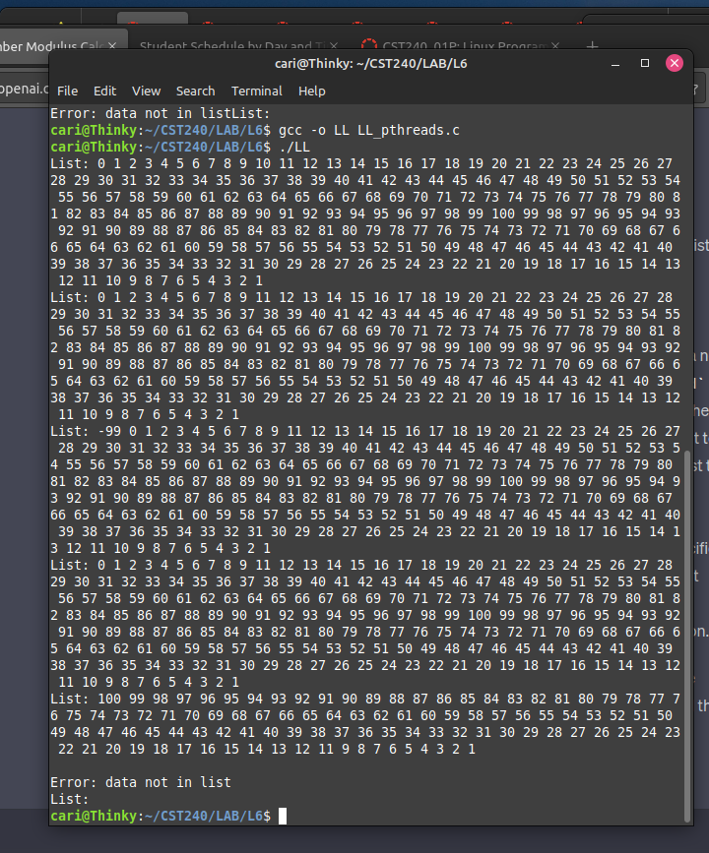

Grading:
Code working correctly: 80 pts
Code documentation: 10 pts
Code testing: 20 pts
Writeup: 30 pts

For documentation, be sure to include your name, the date, the class and assignment at the top.

Also be sure to describe what every major section of code is doing in a comment.

When testing, be sure to test boundary conditions and unexpected data along with expected data.

